AASC-006N-2020

**ANNOUNCEMENT**

**Philippine American Bar Association’s Community Webcast Series**

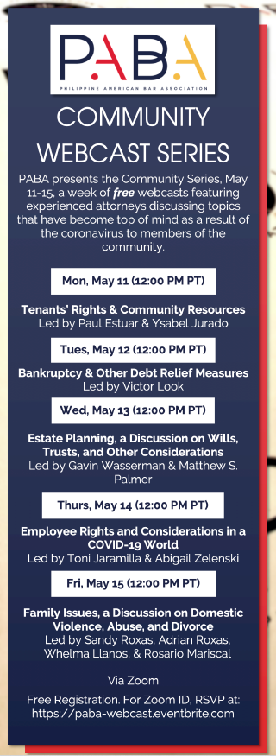

05 May 2020, Los Angeles – The Philippine Consulate General in Los Angeles is pleased to inform the Filipino-American Community that the Philippine American Bar Association (PABA), in partnership with another community organization, Search to Involve Pilipino Americans (SIPA), will be holding a weeklong webcast series, featuring experienced lawyers who will discuss relevant topics and other concerns stemming from the COVID-19 pandemic.

The five-part series will commence on Monday, 11 May 2020 and conclude on Friday, 15 May 2020.

Interested parties are encouraged to register via Eventbrite link, <https://paba-webcast.eventbrite.com>.

PABA is the largest local association of Filipino-American lawyers in the United States, which was formed to address legal issues confronting the Filipino-American community and to meet the professional needs of Fil-Am lawyers in Southern California. END.