Press Release
AASC-021-2020

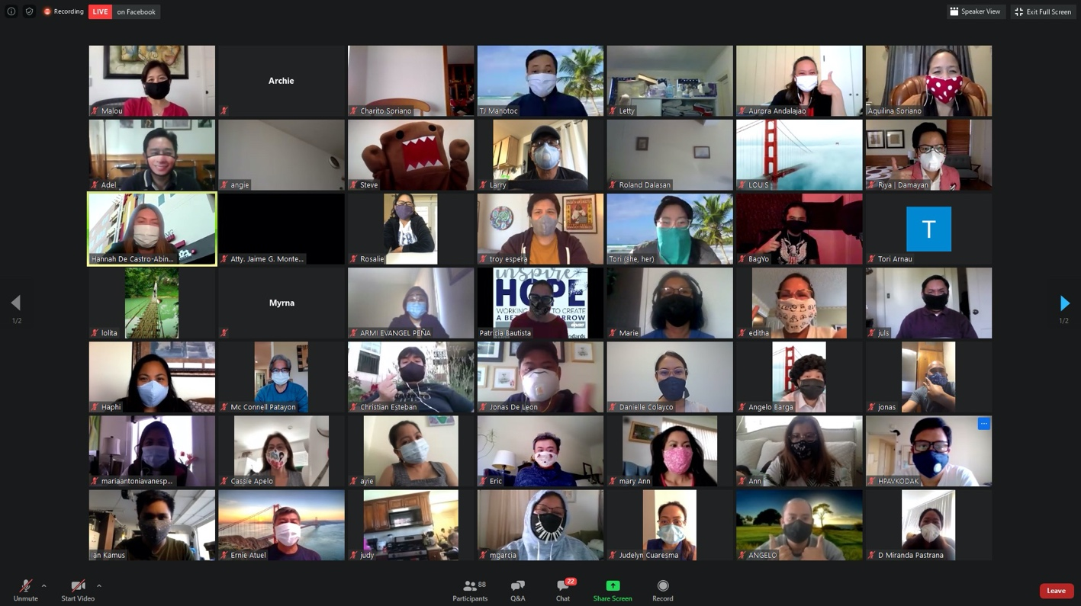
Philcongen LA Participates in 4th PWC Virtual Town Hall

29 April 2020, Los Angeles – Consul General Adelio Angelito S. Cruz once again participated as one of the resource speakers for the Pilipino Workers Center (PWC) of Southern California’s 4th virtual town hall meeting in the afternoon of 27 April 2020.

ConGen underscored the Philippine government’s commitment to extending all possible assistance to overseas Filipinos, regardless of their status in the U.S.A. He emphasized that even if PCG had been on “work-from-home” mode since 19 March 2020, it continues to serve the community and extends appropriate assistance to Filipinos in need. He encourages the Filipino community to email or call the Consulate General for assistance.

ConGen Cruz also mentioned that Philippine Airlines (PAL) will operate special flights on 29 April 2020 and 01 May 2020 from Los Angeles to Manila. Those who wish to avail of PAL’s special flight may directly call the airline’s hotline or visit its official website.

He, however, reminded returning overseas Filipinos to strictly observe quarantine protocols upon arrival in Manila since the Philippines has extended its enhanced community quarantine in Luzon. He pointed out that only Filipino and dual citizens are allowed entry in the Philippines. Foreigners, as well as U.S. citizens of Filipino descent, who have not reacquired their Philippine citizenship are not yet allowed entry in the Philippines.

ConGen Cruz added that that the Department is preparing a special video presentation to pay tribute to all Filipino front-liners all over the world. He strongly encouraged everyone who wanted to participate to submit a 30-second video clip of front-liners in-action or at work.

Finally, ConGen Cruz thanked PWC for hosting said town hall meeting, as well as the Philippine Embassy and other PHL Foreign Service Posts in the U.S.A. for their continued commitment in serving our kababayan in America.

Other resource speakers in the town hall were Angie Aramayo, Central Area Representative from the Office of Mayor Eric Garcetti; TJ Manotoc, ABS-CBN North America News Bureau Chief; Kimberly Alvarenga, Director of the California Domestic Workers Coalition; Rigoberto Reyes, Executive Director of the Office of Immigrant Affairs-County of Los Angeles Board of Supervisors; Francia Nava, Program Advocate of My Health LA; Patricia Bautista, Human Services Administrator of the Los Angeles County Department of Public Social Services Intergovernmental Relations; Riya Ortiz, Lead Organizer & Case Manager of Damayan Migrant Workers Association, New York; Malou Villacisneros, External Relations Director, PWC; and Senator Kamala Harris, U.S. Senator for California.

The Filipino Channel-produced video presentation entitled “Heroes Without Capes” was presented during the webinar as a simple tribute to fearless Filipino front-liners.

Ms. Aquilina Versoza, PWC Executive Director, who facilitated the webinar, updated the community on PWC’s various programs in response to the COVID-19 pandemic (i.e. Care Box, Care Meals and Care Fund) and encouraged everyone to avail of the free COVID-19 testing provided by Los Angeles County.

Before concluding virtual meeting, she requested all participants to wear their face covering for a group shot (photo above). The event was participated in by around 200 community members from the west all the way to the east coast. END.

